Benha University  Faculty of Engineering at Shoubra  Energy Engineering Dep. |  | Mid Term Exam (Fall 2018)  Date: Monday (19/3/2018)  Subject: Electronic Engineering  Duration: 1 hour
- Answer all the following questions |  | - No. of questions : 2  - Total Mark: 30 Marks
Question (1) (15 Marks)
- Give one application for: (Diode, Zener diode, LED) (3 marks)
Diode : in rectifier circuits Zener : regulator in power supply LED: indicator
- The ideal diode acts as short circuit in forward connection and acts as open circuit for reverse. (2 marks)
- Practical diode acts as battery in forward connection and acts as open circuit For reverse. (2 marks)
- Silicon diode needs 0.7V to operate while Germanium diode require 0.3V to operate. (2 marks)
- What diode is similar to zener diode when it connected in forward? Si diode (1 marks)
- Zener diode 5V, mean that it is battery of 0.7V In forward and battery of 5.1V In reverse. (2 marks)
- Sketch the block diagram of a 5v power supply and show the waveform after each block. (3 marks)
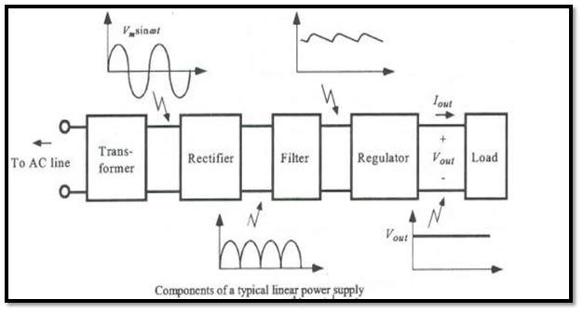
Question (2) (15 Marks)
- Determine and sketch the peak value of the output voltage and PIV for the circuit in Fig. 1.
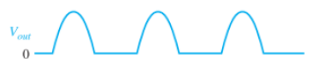
Vsec=0.5Vprim=60Vrms
Vsec(p)=1.414*60=84.84V
Vout=84.84-0.7= 84.14 V
PIV = 84.84V

- A zener diode used as a regulator at 6.2V, connected in shunt regulation with unknown R_{L}. If the DC input was 5V and the Rs= 10 Ω, calculate the value of the R_{L} that makes the power dissipated through the Rs be 1W. (6 marks)
Solution:
Is= P/(Rs)²=0.01A
VIN <Vz
So zener is off (open circuit)
So Is = IL = 0.01A
RL+RL = VIN / (Is) = 5/0.01=500
RL=500-10=490 Ω

- Calculate the current through 48 Ω in the circuit shown in the Figure (2). Assume all diodes to be ideal.
Solution:
D1, D3 on & short circuit
D2 , D4 off & open circuit
So I = 10 / 48 = 0.208A
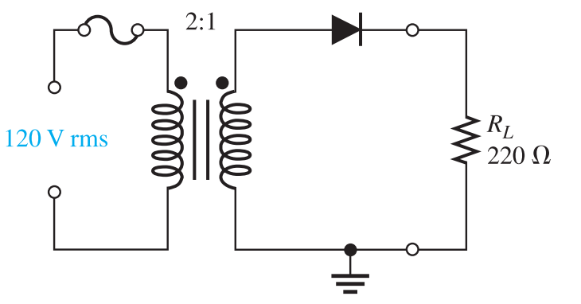 | 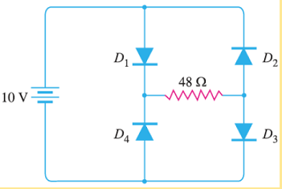
Fig. 1 | Fig. 2
Good Luck,
Prof. Dr. Hala M. Abdelkader
Dr. Moataz Elsherbini

